GNG2101 Report Template

[TITLE]

Submitted by

[TEAM IDENTIFIER EG. B2A, Team 12]

Pierre Allard, 300102131

Haonan Zhou, 300264669

Wanis Hassan, 300255946

[TEAM MEMBER, STUDENT ID]

Date

University of Ottawa

#### 

Abstract

Table of Contents

Abstract i

Table of Contents ii

List of Figures iii

List of Tables v

List of Acronyms vi

1 Introduction 7

1.1 SUBTITLE 7

1.1.1 SUBTITLE 7

2 Engineering Design Process 8

3 Need Identification and Product Specification Process 9

4 Conceptual Designs 10

5 Project Planning and Feasibility Study 11

6 Analysis: 12

7 Prototyping, Testing and Customer Validation. 13

8 Final Solution 14

9 Business model 15

10 Economic Analysis 16

11 Conclusions and Recommendations for Future Work 17

12 Bibliography 18

APPENDICES 19

APPENDIX I: User Manual 19

APPENDIX II: Design Files 20

APPENDIX III: Other Appendices 21

List of Figures

**No table of figures entries found.**

List of Tables

**No table of figures entries found.**

List of Acronyms

|  |  |
| --- | --- |
| **Acronym** | **Definition** |
|  |  |
|  |  |
|  |  |
|  |  |
|  |  |
|  |  |
|  |  |
|  |  |
|  |  |
|  |  |
|  |  |
|  |  |

# Introduction

## Client Feedback

During this client meeting we were able to ask questions that would directly affect the design of our product. As we mentioned before during previous deliverable, we would like for our software to be an executable instead of a web-based application but before going forward with this decision we used this client meeting to get the thoughts of the client on this decision. The client communicated that if the executable was easy to download there would be no problem with this change. The client also added that a “handful of people” would be using this product she also specified that around 2 to 3 people should be able to use this software at once.

The client mentioned certain features or desires that she would like included in the software. The software should be able to convert both English and French text documents to an audio file respecting the language of the original text. It should also be noted that if the text document submitted to be converted is very large, the conversion of the audio would be done in parts so for example if a novel has 13 chapters, we will want to produce an audio file for each chapter instead of 1 large audio file for the whole novel. The client specified that the conversion from text to audio should not take long, they mentioned that the conversion time should not be over an hour, but our goal is for the conversion time to be much lower. The client was also very adamant that the usability of the software was much more important than the design however it would be ideal if this software could also be updated or improved in the future by others.

# Product Prototype

## Bill Of Materials

The project is purely software based. This allows for the use of existing open-source programs. The estimated cost at this time is zero dollars. Open source software will be credited in documentation of the product and prototype.

## Critical Assumptions

The team will be assuming that the python library for text to speech using Google’s API can be integrated into an executable. In addition, it will be assumed that a compressed python executable will be able to run on the library computers. This will be included in testing in order to minimize the chance of an antivirus or university software blocking the application.

## Documentation

For our prototype it should be a conversion tool. To use it the users should first login the application and then upload the file that they want to convert. After that, the application will convert the file into text automatically, and divided it into different chapters. For second step, the users should choose a language they want (English or French), and then the application will help the users to get the audio file with the language they want. And the final step for the users is to download the file in order to listen it.

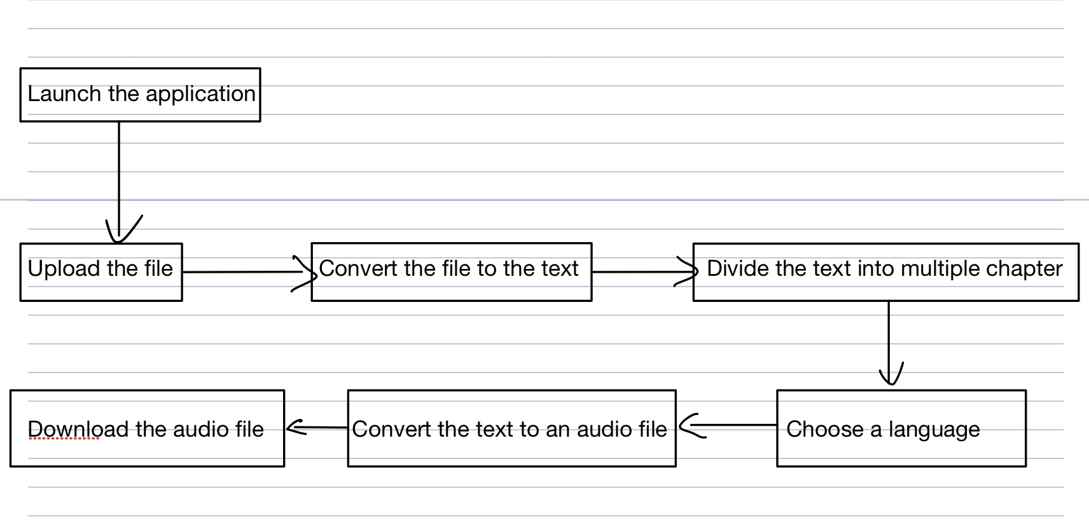

The prototype consists of a UI design, and code that executes commands from each of the required libraries. The code is written in python and compressed into an executable. The following is the testable prototype:

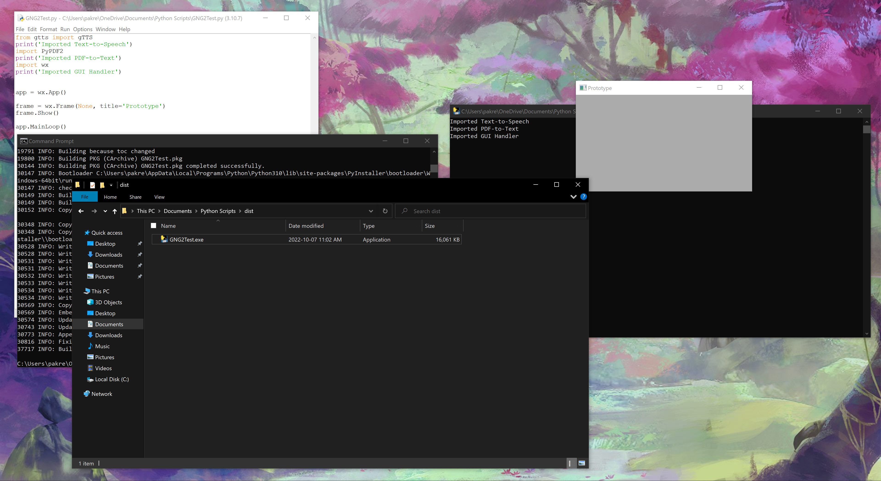

**3.4 Testing**

The following tests have been performed:

* The prototype user interface has been shown to a range of users.
* The prototype has been launched on a variety of computers.
* Each library is downloaded, installed and tested by executing a single command exclusive to that library.

The results are that the UI is easily understood, and did not pose any issue to those reasonably competent with the basic functions of a windows computer.

The program is capable of being launched on the following computers:

Each library is able to be used.

You can use multiple sections for this part if it helps clarify the report.

# Next Client Meeting

Summarize your lessons learned and your work and suggest the most productive avenues for future work.

APPENDICES

APPENDIX I:

Use this section to include your work that is not part of the central subject of the report.